**Task Performance**

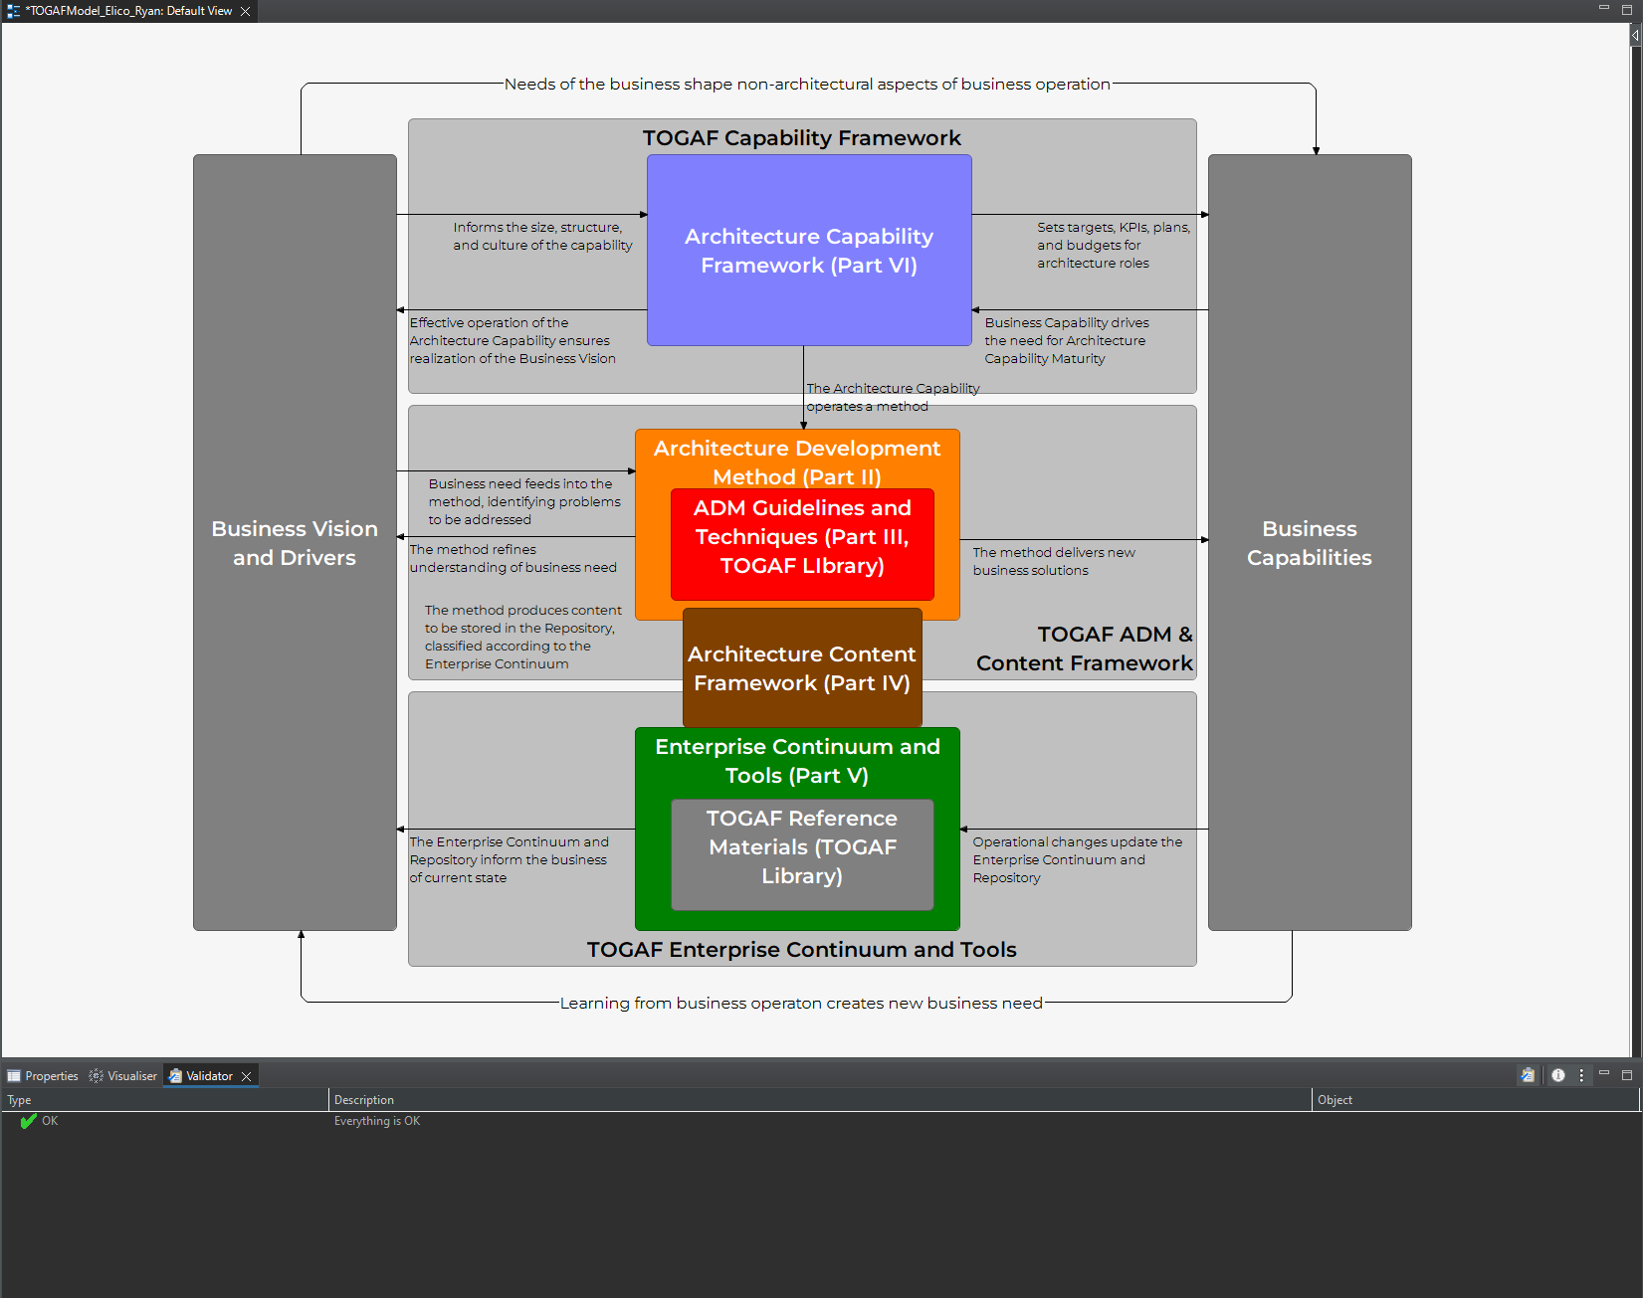Architecture Development Method of TOGAF in Archi

I employed the Archi application to craft an ArchiMate diagram representing the TOGAF framework, a task that began with meticulous planning to define component relationships. Upon launching Archi, I configured the canvas with ArchiMate notation and incorporated essential elements like Business Vision and ADM, establishing meaningful linkages. Labels and descriptions added context while stylistic choices enhanced visual clarity, all the while iteratively reviewing and refining the diagram for accuracy. I saved the project and exported the diagram for sharing or presentations. Archi's user-friendly interface and ArchiMate support significantly facilitated the challenging endeavor of visually conveying the TOGAF framework, making it accessible and effective for a student such as myself. This diagram underscores the importance of Business Vision and Drivers as the bedrock of enterprise architecture, driving organizational goals and challenges. It further delves into the structured Architecture Development Method (ADM), consisting of multiple phases with specific deliverables, acting as a roadmap for enterprise architecture development. The Architecture Content Framework (ACF) is defined, detailing crucial artifacts, their role in describing current and future states, and the transition strategy. The diagram emphasizes the role of the Enterprise Continuum and Tools in understanding enterprise relationships and supporting architecture development and maintenance. The TOGAF framework stands as a comprehensive and widely adopted approach across organizations, irrespective of their size or industry, effectively aligning business objectives with architectural strategies.